eTAAP

Technical Design Document

*Version 1.1*

Contents

Introduction 4

− Purpose 4

− Scope 4

− Document Organization 4

− Audience 5

− Acronyms, Abbreviations, Terms and Definitions 5

Design Overview 5

Approach 5

Architectural Goals and Constraints 5

Guiding Principles 6

− Scalable 6

− Flexible 6

− Standards-Based 6

− Design Patterns 6

− Design Principles 7

Topology Diagram 7

Application Architecture 8

Selenium Integration 10

Appium Integration 10

External Integration 11

eTAAP Control Flow Diagram 11

eTAAP Dashboard 12

Package Structure View 14

Object Model 17

Application Implementation 19

Assumptions and Constraints 21

Revision History

|  |  |  |  |
| --- | --- | --- | --- |
| **Version** | **Date** | **Description** | **Author** |
|  |  |  |  |
| 1.0 | 10/03/2014 | Initial Draft | Rajesh Pandey |
| 1.0 | 10/17/2014 | Initial Draft | Rajeswari T |
| 1.0 | 10/24/2014 | Initial Draft | Lavanya K |
| 1.0 | 10/03/2014 | Released version | Rajesh Pandey |
| 1.1 | 05/15/2014 | Released version | Rajesh Pandey |
|  |  |  |  |

Figure 1 - eTAAP Topology Diagram 8

Figure 2 - eTAAP Logical Diagram 9

Figure 3 - eTAAP Control Flow Diagram 10

Figure 4 - eTAAP Control Flow Diagram 12

Figure 5 - Dashboard Topology Diagram 13

Figure 6 - eTAAP Dashboard Architecture 13

Figure 7 - com.etouch.taf.core structure 15

Figure 8 - com.etouch.taf.tools structure 16

Figure 9 - com.etouch.taf.webui structure 16

Figure 10 - com.etouch.taf.mobile structure 17

Figure 11 - com.etouch.taf.desktop structure 17

Figure 12 - com.etouch.etaapui structure 17

Figure 13 - eTAAP Object Diagram 20

Figure 14 - eTAAP Deployment structure 21

Figure 15 - eTAAP deployment Diagram 21

# Introduction

This document provides a comprehensive architectural overview to outline the technical design of the eTouch Test Automation Accelerator Platform (eTAAP). The document depicts the technical aspects eTAAP and is intended to capture and convey the significant architectural design decisions which have been made in creation eTAAP platform.

eTAAP is primarily based on the open source technologies like Selenium, Appium etc. It also integrates with COTS and SaaS products like JIRA, Rally, Sauce Labs, Perfecto mobile etc.

## Purpose

The purpose of this document is to outline the technical design of the eTouch Test Automation Accelerator Platform (eTAAP). Its main purpose is to –

* Provide detailed description on the technical design of eTAAP.
* Detail the functionality, which will be provided by each component or group of components and show how the various components interact in the design
* Provide a basis for the eTAAP detailed design and development

This document is not intended to address installation and configuration details of the actual implementation. Installation and configuration details are provided in eTAAP developer’s guides/documentation.

As is true with any high level design, this document will be updated and refined based on changing requirements.

## Scope

The Application Design outlined in this document builds upon the scope defined in the Requirements phase.

## Document Organization

This document is organized into the following sections:

|  |  |
| --- | --- |
| Introduction | Provides information related to this document (e.g. purpose, term definitions etc.) |
| Design Overview | Describes the approach, architectural goals and constraints, Guiding principles, Java Design patterns used in design and development |
| Topology Diagram | Describes the various system components and the integration between them |
| Application architecture | Describe the application architecture in terms of different layers of application. Description of the presentation layer, business layer, data access layer and resource layer and their relationship to each other. |
| Object Model | Describes the conceptual representation of the problem domain of an application that embodies the business rules being automated and is usually represented with Class diagram |
| Database Architecture | Describes the overall Data model for the eTAAP |
| Assumptions and Constraints | Details various assumptions made during design and development of the eTAAP |
| Appendix A | Describes Acronyms, Abbreviations, Terms and Definitions |
| Appendix B | Lists all products and tools used in the design and development |
| Appendix C | Lists all the configuration files used in implementation |
| Appendix D | Describes the data dictionary |

## Audience

The intended audiences for this document are eTouch Stakeholders, the project development teams, technical architects, database designers, testers and clients, who are/will use the eTAAP .

## Acronyms, Abbreviations, Terms and Definitions

Please refer to Appendix A for a list of all acronyms and abbreviations.

# Design Overview

## Approach

This document is created and extended in multiple phases over the course of the eTAAP development –

* *Requirements Phase* – During the Requirements Phase, the initial version of this document is created,describing the candidate architecture to be validated in the System Design Phase.
* *System Design Phase* – During the System Design phase, the Evolutionary Prototype is created and thisdocument is finalized by establishing a sound architectural foundation for the Construction Phase.
* *Construction Phase* – During the Construction Phase, this document is not expected to changeradically; it is mainly updated to reflect changes in any interface definitions.
* *Ongoing enhancements* – During the Ongoing enhancements, there will bemodification/addition of functionality to the tool, which will be updated as per the release cycle.

## Architectural Goals and Constraints

The overall architecture goals of the system are to provide a highly available and scalable, test automation framework to meet the following requirements.

* Run regression tests at a scheduled frequency
* Web interface to configure the regression, smoke
* Reduce testing staff
* Find more bugs
* Consistency in test results
* Reduce elapsed time for testing
* Automate 60-90% of the testing
* Run tests tedious and error-prone if run manually
* Gain confidence in the system
* Reduce the number of defects found by users
* Dashboard to view the test results

A key Architectural goal is to leverage industry best practices for designing and developing a scalable, enterprise-wide test automation framework. To meet this goal, the design of the eTAAP is based on core J2EE patterns as well as the industry standard development guidelines. For integrating open source tools like Selenium, Appium etc, a set of abstract functions are developed, which provides the required hooks to back to the tool.

## Guiding Principles

Guiding principles provide a foundation upon which to develop the target architecture for the eTAAP, in part by setting the standards and measures that the framework must satisfy. These in turn drive design principles that can be used to validate the design and ensure that it is aligned with overall Architecture, Design Principles and Standards.

Some of the guiding principles that will be followed during the eTAAP design and development are outlined below.

## Scalable

Scalability is the ability of the platform to scale both up and down to support varying numbers of users or transaction volumes. The application should be able to scale horizontally (by adding more servers for testbeds etc) or vertically (by increasing hardware capacity or software efficiency).

## Flexible

Flexibility is the ability of the application to adapt and evolve to accommodate new requirements without affecting the existing operations. This relies on a modular architecture, which isolates the complexity of integration, open-source/COTS automation tools, presentation, and business logic from each other in order to allow for the easy integration of new technologies and processes within the application.

## Standards-Based

eTAAP will comply with established industry standards. The standards-compliance will not only apply to application development but also to design, platform/infrastructure and other parts of the eTAAP. Examples of standards include HTML, XML, J2EE, and JSP, reading external data sources, integration with third party softwares/SaaS etc

## Design Patterns

Design patterns are elements of reusable object oriented software. A design pattern catalog is a repository of design patterns. Use of such patterns makes the design of an application transparent. These patterns have been used successfully by developers in their respective fields, and therefore, the pros and cons of the pattern (as well as implementation issues) are known beforehand. All design patterns are reusable and can be adapted to particular contexts.

Below are the key designs patterns which are used in this framework–

1. **Front Controller:** The front controller design pattern is used to provide a centralized request handling mechanism so that all requests will be handled by a single handler. **TafExecutor** class in test script project acts as a front controller to service the test request configured in **devConfig.yml**.
2. **Business Delegate:** Business Delegate design pattern provides a single entry point for client entities to provide access to Business Service methods. **executeTestSuite** utility in **TafExecutor** acts as entry point to delegate the test execution to the appropriate services.
3. **Factory Pattern**: Factory design pattern is one of the types of creational pattern. Using Factory pattern, the object is created without exposing the creation logic to the client and refer to newly created object using a common interface. Major modules in **eTAAP** framework like driver, webui, defect are built using factory design pattern.
4. **Dependency Injection:** The Dependency injection pattern creates the needed instances, and "**injects**" them into the object. Dependency Injection pattern is used to switch the implementation of **ITafElement** at run time based on web or mobile test type.

## Design Principles

Best practices and design principles are applied in the following main areas –

1. Easy way to write test-cases with the knowledge JAVA and abstract methods published by eTAAP. Writing test-cases should not require the knowledge of Selenium/Appium level APIs etc.
2. Ability to make one change, in one place; that will automatically updates a large number of test cases.
3. Full support for “Keyword driven” testing. eTAAP architecture should be application and tool independent. The data driven aspect of the overall architecture is a spreadsheet, or common delimited file that contains one row of data per test cases.
4. For AUT, based on responsive design approach, one test-case should be good enough to run across multiple platforms and across browsers.
5. Repeatable and consistent outcome. As long as the application does not change, the results of the testing should be consistent, regardless of the number of executions.
6. Reusability of test code
7. Extended reporting capability
8. End to end test automation

# Topology Diagram

The diagram below provides a illustration of the System Architecture along with various system components that will be used in architecting the Online

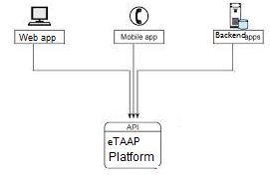

Figure 1 - eTAAP Topology Diagram

Interaction of software components along with its responsibilities is explained below –

**Web Application** – A web application or web app is any software that runs in a web browser. It is created in a browser-supported programming language (such as the combination of JavaScript, HTML and CSS) and relies on a web browser to render the application.

**Mobile Application** – A mobile application is a computer program designed to run on smartphones, tablet computers and other mobile devices. Apps are usually available through application distribution platforms, and are typically operated by the owner of the mobile operating system, such as the Apple App Store, Google Play, Windows Phone Store, and BlackBerry App World. There are primarily three types of mobile apps:

* **Native Application** are specific to a given mobile platform (iOS or Android) using the development tools and language that the respective platform supports (e.g., Xcode and Objective-C with iOS, Eclipse and Java with Android). Native apps look and perform the best.
* **HTML5 Application** use standard web technologies—typically HTML5, JavaScript and CSS. This write-once-run-anywhere approach to mobile development creates cross-platform mobile applications that work on multiple devices.
* **Hybrid Application** make it possible to embed HTML5 apps inside a thin native container, combining the best (and worst) elements of native and HTML5 apps.

**Backend Application** – Backend app testing will include web-services (SOAP, REST), database testing and custom API testing with the backend systems.

* **Web-services (SOAP, REST) testing**- this functionality covers web service inspection, invoking, development, simulation and mocking, functional testing, load and compliance testing. The Web Services platform can be served by .NET, J2EE, Perl, PHP, etc.
* **Database Testing** – this will include the data validation with backend database RDBMS, or repositories based on file-systems
* **Database Testing** – this will include the data validation with backend database RDBMS, or repositories based on file-systems

# Application Architecture

Application architecture defines the various components and their interactions in context of a whole system. Application architecture is the critical software that bridges the architectural gap between the application server and the application’s business logic, thereby eliminating the complexities and excessive costs of constructing, deploying and managing distributed enterprise applications.

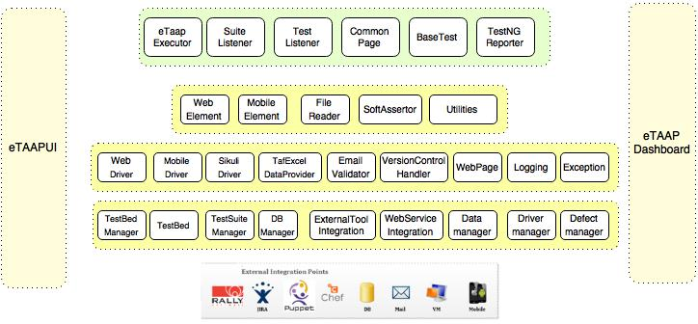

Figure 2 - eTAAP Logical Diagram

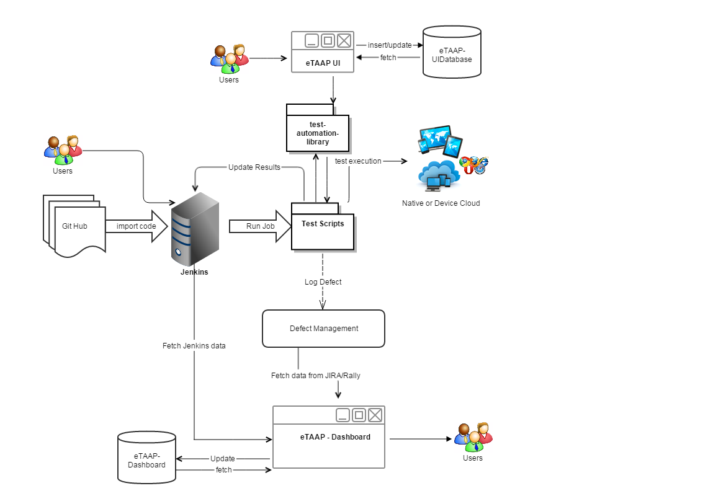

Figure 3 - eTAAP Control Flow Diagram

Below tables list out the core components of the eTAAP library

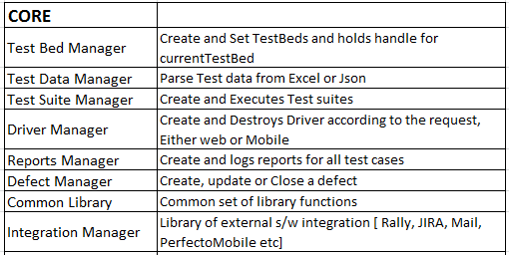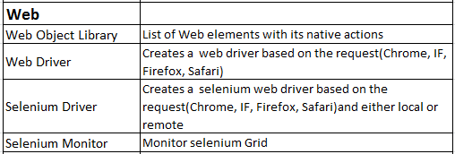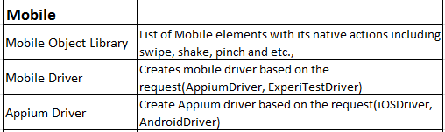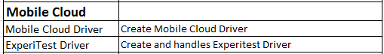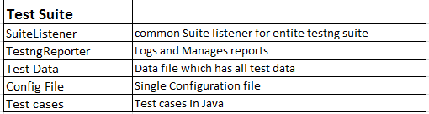

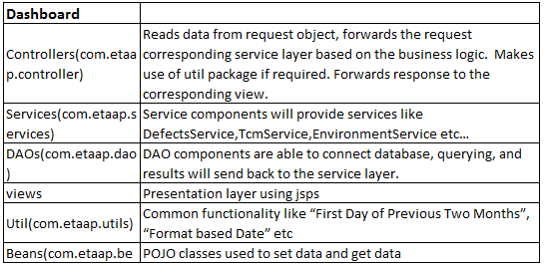 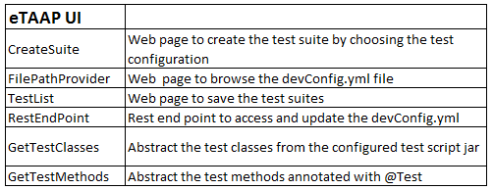

Figure 4 - eTAAP Key Components

< Few lines of description for each of the above table core components >

## Selenium Integration

eTAAP using selenium at its core, for testing the web applications (AUT). Based on the current testBed details such as Browser name, version, platform, eTAAP driver manager will create WebDriver. It also supports selenium remote web driver, based on the configuration information in devconfig.yml. To test the AUT using selenium grid, just set the “environment to remote”, in the devconfig.yml file and define the testBedName in mvn goal with –DTESTBEDNAME parameter.

eTAAP supports all the basic features of selenium such as implicit, explicit waits and all wait conditions. Webelements will be created during the execution of the test based on element identification values

## Appium Integration

eTAAP creates Appium Driver for mobile testing ,based on the input testBed configuration, such as mobile platform, bowser, app package, app activity, bundle id. It also supports IOSDriver and AndroidDriver provided by Appium. eTAAP library has the utilities to access mobile actions such as swipe, scroll, zoom, rotate etc. provided by Appium.

AppiumLauncher module in eTAAP framework takes care of launching and closing the appium session automatically for mobile testing. eTAAP supports the parallel execution of test scripts on multiple mobile devices by launching multiple appium sessions on different ports.

eTAAP is loosely coupled with Appium to make sure that there are no changes in test script code when user wants to move away from Appium.

## External Integration

* **JIRA integration:** JIRA module is integrated in eTAAP Framework for logging the defects automatically whenever a test case fails. JIRA REST API is used to create the issue with defect notes and video link, attach the screenshot and update the verdict as pass/fail.
* **Rally Integration:** Rally module is integrated in eTAAP Framework for logging the defects automatically whenever a test case fails. Rally REST API is used to create the issue with defect notes and video link, attach the screenshot and update the verdict as pass/fail.
* **Email integration:** eTAAP framework is integrated with mail module which is used to access the user configured mailbox which might be required during the test execution. The mail module is built using java mail API.
* **Perfecto Mobile integration:** Perfecto mobile is SAAS based cloud lab which provides on-demand mobile testing infrastructure. eTAAP has the capability to access the Perfecto mobile devices using its selenium plugin.
* **Device AnyWhere Integration:** Device AnyWhere also provides the largest library of real, mobile devices from anywhere. eTAAP is integrated with Device AnyWhere cloud using its api.
* **ExperiTest Integration:** Experitest provides the tools to set up the mobile cloud using server - client based architecture to access the mobile devices for testing. Experitest driver module is built in eTAAP framework to access the mobile cloud devices using Experitest’s selenium api.
* **Continuous Integration:** eTAAP supports continuous integration using Jenkins. It has the capability to support selenium grid as well. eTAAP is integrated with code coverage tools like Sonar and Cobertura for generating the code coverage reports.
* **Auto Provisioning(Chef/Puppet):** eTAAP has a pre-configured set of configuration files for the orchestration of creating the test environment using Chef and Puppet tools.

## eTAAP Control Flow Diagram

In this section we detail eTAAP flow, when a request to execute one or more testcase is invoked.

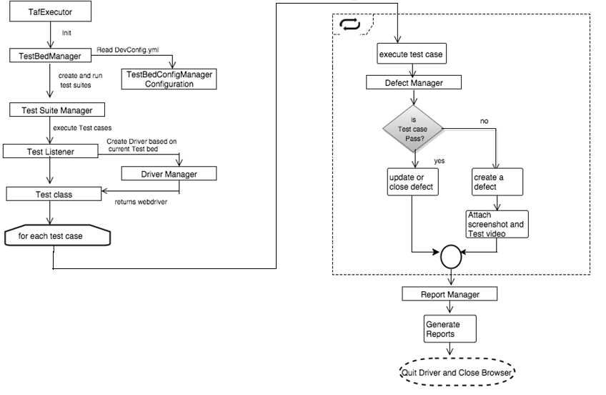

Figure 4 - eTAAP Control Flow Diagram

# eTAAP Dashboard

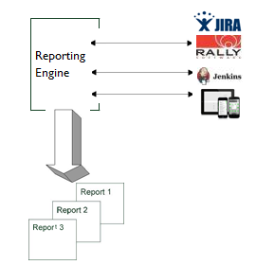

Figure 5 - Dashboard Topology Diagram

eTAAP provides an standalone dashboard web application. Periodically/on-demand the dashboard application pull the data from CI tools like Jenkins and bug tracking tools like JIRA and Rally and stores it locally for archival viewing of reports ( Fig above)

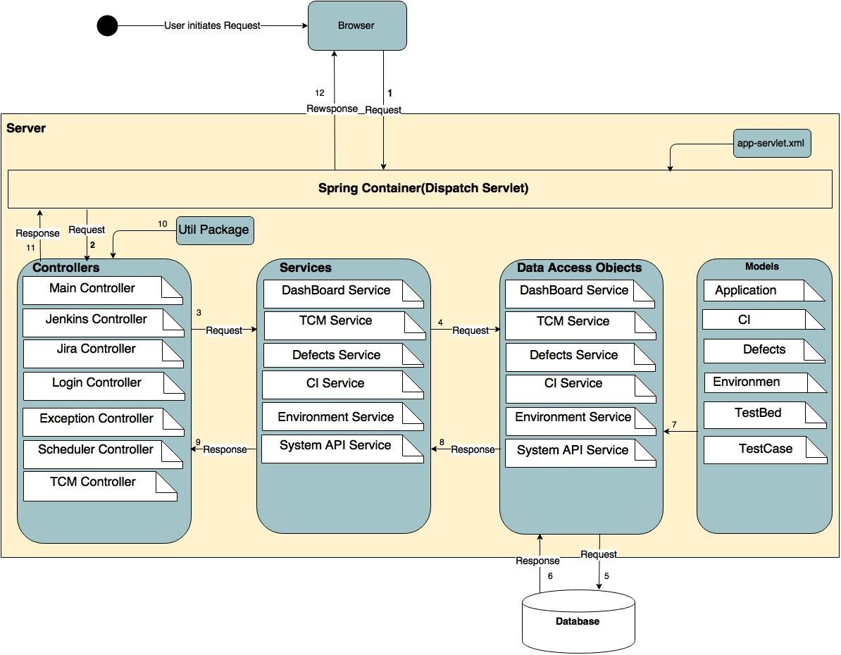

Figure 6 - eTAAP Dashboard Architecture

Dashboard is using Java Spring framework where a user request:

* Travel from Sprint container through Sprint Servlet (app-serverlet.xml) to bind the beans with URL pattern *( Step #1 )*
* To the Spring controllers *( Step #3 )*
* Controller read the data from request object and pass the information to the service layer
* Where it further gets forwarded to the DAO *( Step #3 )*
* And then to the database to access the required data set *( Step #4,#5 )*
* And back to DOA to get the corresponding model *( Step #6, #7 )*
* From here the information travel back through the controller, Util package to perform specific operation and finally to the browser*( Step #8, #9 )*

Return control back to browser*( Step #10, #11,#12 )*

## Package Structure View

1. **Package com.etouch.taf.core** : Provides the classes necessary for core functionalities of framework such as configuration classes, driver creation, application exception, data manager

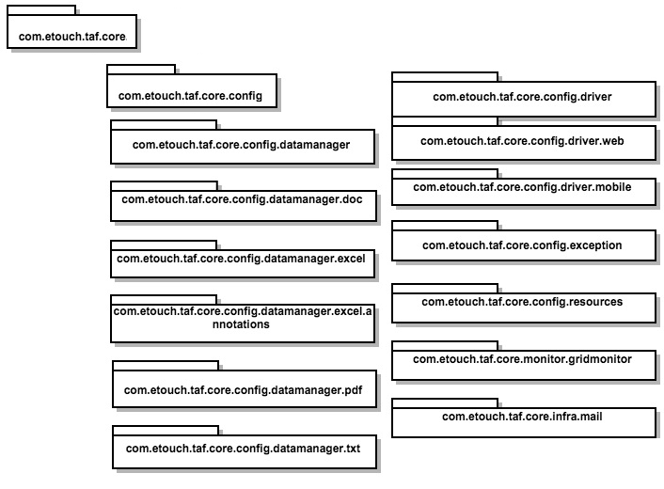

Figure 7 - com.etouch.taf.core structure

1. **Package com.etouch.tools:** Tools package provides classes necessary for external integration tools such as TFS, JIRA, Rally

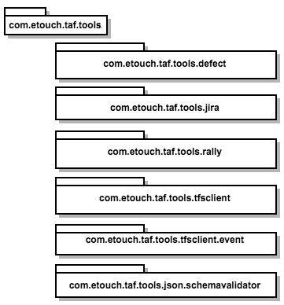

Figure 8 - com.etouch.taf.tools structure

1. **Package com.etouch.taf.webui**: This package provides classes necessary for web testing. It helps to create webDrivers, web elements and any action performs on web elements

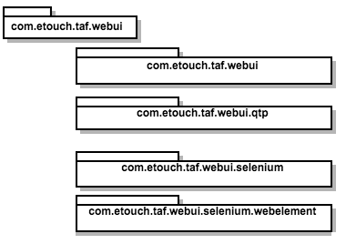

Figure 9 - com.etouch.taf.webui structure

1. **Package com.etouch.taf.mobile:** This package provides classes necessary for mobile testing. It helps to create drivers for native, hybrid and mobileweb apps. Helps to create mobile elements and actions perform on mobile elements

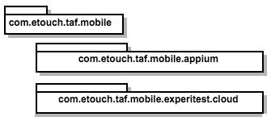

Figure 10 - com.etouch.taf.mobile structure

1. **Package com.etouch.desktop.sikuli:** Provides functionalities that help to create sikuli driver for desktop testing.

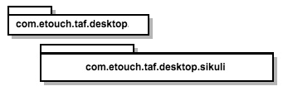

Figure 11 - com.etouch.taf.desktop structure

1. **Package com.etouch.etaapui:** This package allows users to create/update the “devconfig.yml” via a user interface. It also provides a web interface to create/edit/save/invoke the ‘regression suites’ for testing.

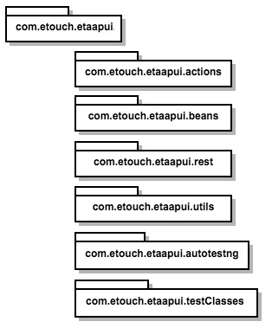

Figure 12 - com.etouch.etaapui structure

1. **Package com.etouch.dashboard:**

Add eTAAP UI and dashboard component also

## Object Model

Object Model is the description of the structure of the objects in a system including their identity, relationships to other objects, attributes, and operations.



Figure 13 - eTAAP Object Diagram

Object Model for eTAAP consists of one or more classes, events, functions, interfaces, methods, namespaces, objects, and properties.

# Application Implementation

The Application Deployment Structure is shown below. eTAAP will be deployed as JAR (Java Archive) file using Jenkins CI or build scripts tools like ANT etc.

|  |  |  |  |
| --- | --- | --- | --- |
|  |  |  |  |
|  |  | **Directory Structure:** |  |
|  |  |  |  |
| JAR |  | Java Archive is used to package java libraries and EJB components |  |
|  |  |  |  |

Below is the directory structure of the eTAAP deployed components.

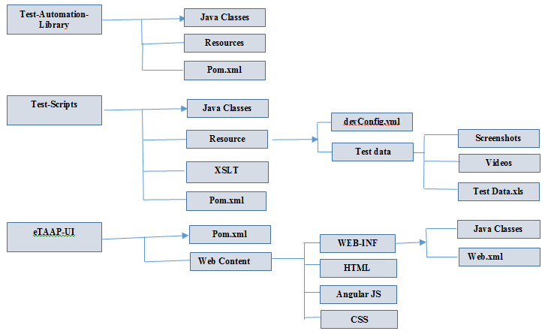

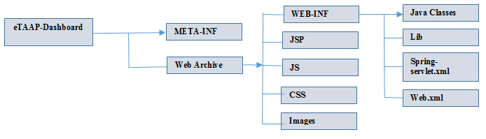

Figure 14 - eTAAP Deployment structure

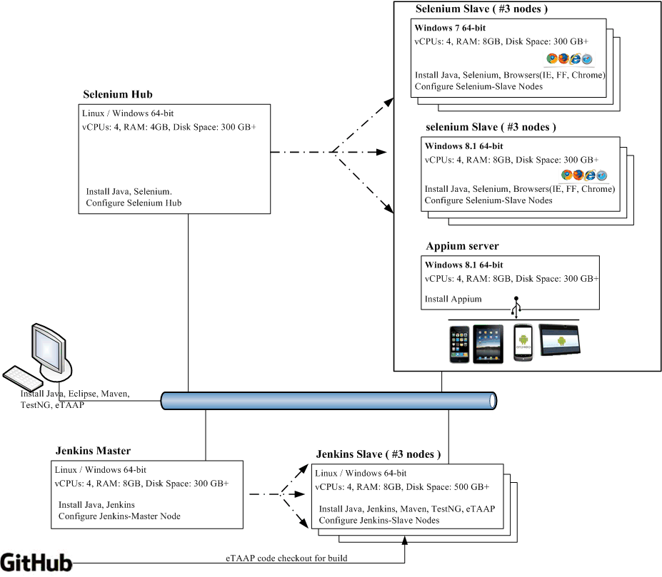

Figure 15 - eTAAP deployment Diagram

|  |  |
| --- | --- |
| **Component Name** | **Component Description** |
| CI Jenkins Master | Used for triggering automated tests. It receives the requests from end users for executing the tests. The automated tests will be triggered using Jenkins Master: |
| It delegates the incoming requests to a Jenkins slave, which interacts with Selenium grid |
|  |
| CI Jenkins Slave(1+) | Jenkins instance, which received the request from Jenkins master, gets the automation code from Source Code Management system e.g. SVN,GitHub |
| Compiles the downloaded automation framework(eTAAP) code and thereafter connects to selenium grid (selenium hub and node combination) for initiating the tests. |
| Jenkins slave are especially helpful, when large number of requests have to be executed in parallel. Each slave is dedicated for a specific test execution. |
| Selenium Hub | Selenium hub is a component of selenium grid, which is an entry point for the automated tests. Jenkins slave sends the details for a specific browser, operating system combination and the specific tests to be executed. Depending on the requested browser and operating system combination, it redirects the request to a selenium grid supporting this |
| Selenium Node(1+) | A Selenium grid can have one or more selenium nodes. Each grid is configured for a specific browser and OS combination. On receiving a request from selenium hub, it opens the browser, accesses the application and executes tests. It can open multiple browser instances to assist in parallel test execution. |
| Appium Node | Appium is an open source mobile automation tool for iOS and Android. Appium can test native and hybrid applications, and can even be used to automate Mobile Safari on iOS |

# Assumptions and Constraints

While the guiding principles establish the general values that the target architecture should consider, a number of assumptions were made about both the infrastructure and general direction for technology.

|  |
| --- |
| **Assumptions and Constraints:** |
| General Architecture principles based on past experiences and eTouch’s Best practices & methodologies will be used in designing the solution |
| Primary client interface for eTAAP will be web browser and most common mobile devices |
|  |
|  |

**Appendix A: Acronyms, Abbreviations, Terms and Definitions**

|  |  |
| --- | --- |
| API | Application Program Interface |
|  |  |
| DHTML | Dynamic Hypertext Markup Language |
| EAR | Enterprise Archive |
| GUI | Graphical User Interface |
|  |  |
| HTML | Hypertext Markup Language |
|  |  |
| HTTP | Hypertext Transfer Protocol |
|  |  |
| SMTP | Simple Mail Transport Protocol – Standard method of delivering |
|  | internet email messages |
| J2EE | Java Enterprise Edition |
|  |  |
| JAR | Java Archive |
|  |  |
| JRE | Java Runtime Environment |
|  |  |
| JSP | Java Server Pages |
|  |  |
| JVM | Java Virtual Machine |
|  |  |
| XML | Extensible Markup Language |
|  |  |
| XSLT | Extensible Style Language Transformation |
|  |  |
| YAML | Yet Another Markup Language |
|  |  |
| AUT | Application Under Test |
|  |  |

**Appendix B: Products & Tools**

The following software components will be utilized in the eTAAP architecture. New versions of software may be released during the development of the system. The implementation of these new versions will be evaluated on an individual basis in determining if and when they will be implemented. Cross compatibility issues must be addressed before implementing any new versions of software products.

|  |  |  |  |  |  |  |  |
| --- | --- | --- | --- | --- | --- | --- | --- |
| Software/Tool | Version |  | Source |  | Description |  |  |
|  |  |  |  |  | |  |  |
| J2SDK | 1.6.x | [http://java.sun.co](http://java.sun.com/)m | | Java SDK for API | |  |  |
| J2EE | 1.6 | [http://java.sun.co](http://java.sun.com/)m | | Java Enterprise Edition for | | |  |
|  |  |  |  | Enterprise services | |  |  |
| GitHub | xx | <http://www.github.com> | | Version Control client | |  |  |
| SoupUI | xx | <http://www.soapui.org/> | | Functional testing tool for API Testing for SOAP, API, REST etc. | | |  |
| Selenium | 2.8.0 | <http://www.seleniumhq.org/> | | Selenium Server | |  |  |
| Appium | xx | <http://appium.io/> | | Automation framework for Mobile Apps | | |  |
| Rally | xx | <https://www.rallydev.com/> | | Project Management/Defect Tracking tool | |  |  |
| Tomcat | 8.0.x | <http://tomcat.apache.org/> | | Apache Tomcat Server | | |  |
| Sonar | xx | <http://www.sonarqube.org/> | | Code quality tool | | |  |
| Maven | 3.2.3 | <http://maven.apache.org/> | | Build Management tool | | |  |
| Jenkins | 1.532.x | <http://jenkins-ci.org/> | | Continuous Integration tool | | |  |
|  |  |  | |  | | |  |
|  |  |  |  |  |  |  |  |

**Appendix C: Configuration files**

Below are some of key configuration files used in eTAAP.

**Application Configuration File**

Below are three key application configuration files -

* **web.xml -** The*Web application descriptor*provides the application server withinformation about the Web resources in the application.
* **pom.xml –** The POM (Project Object Model) file is the Maven configuration file, which includes all the dependencies to be installed for the project/application. For eg: Javax, testng, selenium, siklui, selenium jars. All these jar files will be downloaded to “Maven Dependencies” folder in the workspace.
* **devConfig.yml –** This configuration file includes all the configuration parameters required for all the modules/components like: defect tracking, testNG config, WebConfig, testBeds for both Web and Mobile apps.